HND Software Engineering

Bradford College

Discrete Mathematics

Assignment: 2 - Set Theory Applications

By

Michael Russell (Group 2)

Tutor: ***

Table of Contents

Development of Set Theory 3
Areas of Application 3
Application Examples 4
Example Problem One 4
Example Problem Two 5
Relevance to Software Engineering 6
Bibliography 8
List of References 8

Development of Set Theory

The history of set theory is rather different from the history of most other areas of mathematics. For most areas a long process can usually be traced in which ideas evolve until an ultimate flash of inspiration, often by a number of mathematicians almost simultaneously, produces a discovery of major importance. Set theory however is rather different. It is the creation of one person, Georg Cantor.

Cantor published a six part treatise on set theory from the years 1879 to 1884. This work appears in Mathematische Annalen and it was a brave move by the editor to publish the work despite a growing opposition to Cantor's ideas. The leading figure in the opposition was Kronecker who was an extremely influential figure in the world of mathematics.

(www-history.mcs.st-andrews.ac.uk/history/HistTopics/Beginnings_of_set_theory.html)

Areas of Application

Set theory is used in many areas of computing. Probably the most obvious example is that of databases. In a database, data is grouped together into tables based upon common criteria. The data can be regrouped under different criteria using queries. If a query is made that is a union of one table with another, then the intersection of the two tables is returned. The tables and results of queries can be thought of as sets.

Search engines on the internet work in the same way. They basically are large databases that catalogue websites. This catalogue can be viewed as the universal set. When you ask for a search on certain criteria then the search results, the subset required, are returned.

In programming, sets are employed by the use of arrays and classes. The keyword ‘Class’ stands for classification and this carries with it the thought of sorting and grouping. Arrays are collections of data which can be interregated to provide subsets of data.

Application Examples

The following are examples of set theory showing how sports can be represented by means of Venn Diagrams:

Snooker

The game of snooker is shown in figure 1. It can be seen that players can be commentators, but are not mangers, referees, or members of the governing body. (By players, I mean professional players). Referees are not members of the other four sets and so there is no intersection between them.

Cycling

The team sport of cycling is shown in figure 2. Note that the cyclists are a subset within the team and are composed of the team leader and the domestiques who work for him. The manager is part of the team, as are a set of masseurs who help the riders to recover after races, but they do not ride and are not therefore cyclists. The race director is also part of the Universal Set, which comprises the race personnel, but not part of any team. Other teams have been omitted from the diagram for the sake of clarity; there are usually about a dozen of them in a race!

Example Problem One

Scenario: ‘There are 20 students taking project planning, 30 taking discrete maths and 30 taking C++ programming. There are 5 students taking project planning and discrete maths, 10 takings discrete maths and C++ programming and 4 taking project planning and C++ programming. There are 3 students taking all three courses.’

This problem can be represented using set theory and the use of a Venn diagram:

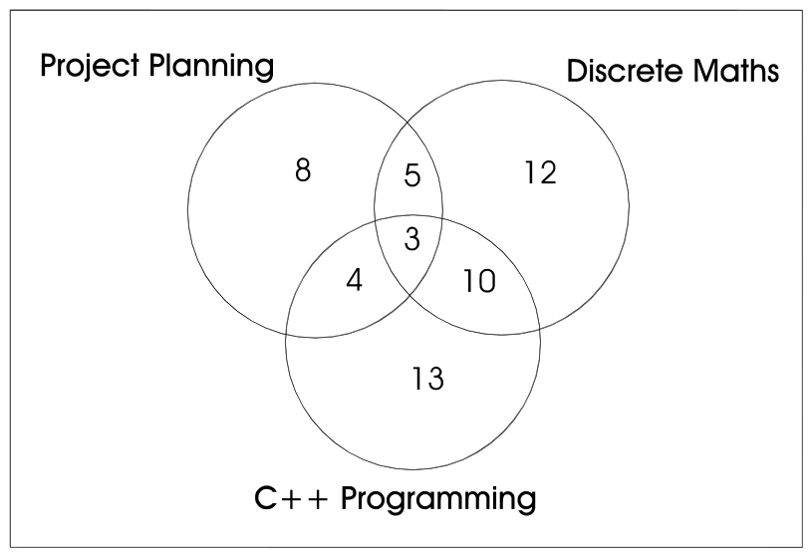

The following questions can now be answered:

Question: How many students are taking at least one of the three courses?

Answer: We simply need to add all the numbers together on the diagram. That is:

8 + 5 + 12 +10 + 13 + 4 + 3 = 55

Question: How many students are taking just project planning?

Answer: It can be seen that 8 students are taking project planning only, as this is the figure in the area of the project planning set that does not intersect with any other subject.

Example Problem Two

Scenario: ‘The student cafeteria offers the following menu:-

- Main dishes –
Chicken curry
Vegetable lasagne
Haddock
- Side dishes
Rice
Chips
Baked potato’

Question: What are the possible meal combinations that can be ordered?

Answer: First, we need to place the above into set notation. If we let set A be Main dishes and set B be Side dishes, then we have the following:

A = { Chicken curry, Vegetable lasagne, Haddock }

B = { Rice, Chips, Baked potato }

To find the cartesian product of A and B we need each element of A to be written as an ordered pair with every element of B. This gives us the following:

A x B = { ( Chicken curry, Rice), (Chicken curry, Chips), (Chicken curry, Baked potato), (Vegetable lasagne, Rice), (Vegetable lasagne, Chips), (Vegetable lasagne, Baked potato), (Haddock, Rice), (Haddock, Chips), (Haddock, Baked potato) }

It can be seen that there are 9 different combinations as we have 9 ordered pairs.

Question: If each meal could be served with or without sauce, show how the set of all possible meals may be written as a product of three sets.

Answer: If we let set C represent sauce, then we have a new set as follows:

C = {with sauce, without sauce}

We therefore need to find the cartesian product A x B x C:

{ ( Chicken curry, Rice, with sauce), ( Chicken curry, Rice, without sauce), (Chicken curry, Chips, with sauce), (Chicken curry, Chips, without sauce), (Chicken curry, Baked potato, with sauce), (Chicken curry, Baked potato, without sauce), (Vegetable lasagne, Rice, with sauce), (Vegetable lasagne, Rice, without sauce), (Vegetable lasagne, Chips, with sauce), (Vegetable lasagne, Chips, without sauce), (Vegetable lasagne, Baked potato, with sauce), (Vegetable lasagne, Baked potato, without sauce), (Haddock, Rice, with sauce), (Haddock, Rice, without sauce), (Haddock, Chips, with sauce), (Haddock, Chips, without sauce), (Haddock, Baked potato, with sauce), (Haddock, Baked potato, without sauce) }

It can be seen that there are 18 ordered pairs in the produce.

Relevance to Software Engineering

Many concepts in computing are expressed using set notation and so sets form a fundamental topic; in fact set theory is used to describe the majority of mathematical topics. (Callan, 1998).

Bibliography

List of References

Callan, R. (1998). Mathematics for Computing. London: Letts Educational.

www-history.mcs.st-andrews.ac.uk/history/HistTopics/Beginnings_of_set_theory.html

